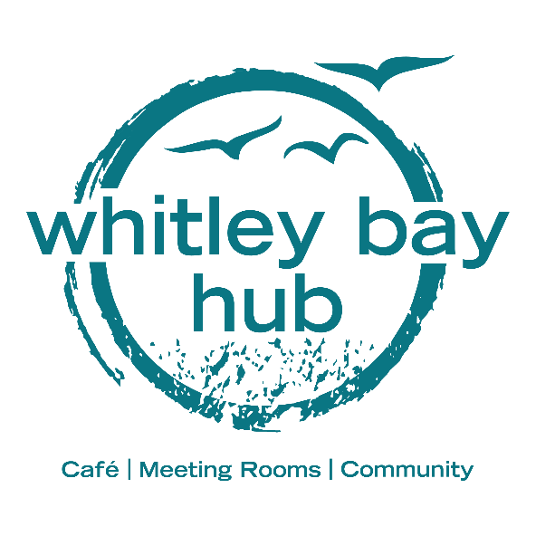
Return completed booking form to hello@whitleybaybiglocal.org
See our website www.whitleybaybiglocal.org for photos and other info
For further information or support, please contact 0191 252 3570

Whitley Bay Hub
Room Booking Form and price information
Standard Rate
Room information – standard rate
You can use the booking form to book any of our rooms. Basic details are below. More information can be found on our website, www.whitleybaybiglocal.org
Discounted rates are available for charities and community organisations. Please request the discounted rate information if you believe you qualify

Room | Conditions | Basic details | Dry hire price
Ground floor and garden exclusive | Only available whilst café is not operational | Max occupancy 119. Set up as a café, activity area left clear | £40 ph  £120 half day  £175 full day
Ground floor meeting | Available whilst café is operating and not booked for an exclusive event | Max occupancy 20. Left clear for your activity. Café may be open and operational during your booking | £12.50 ph
First floor Activity room |  | Max occupancy 59. Left clear for your activity. Room can be set up to your requirements for an additional fee | £20 per hour  £60 half day  £100 full day
Pop-ups | Available during café opening hours | Book a pop-up stand or table in the café area | From £0 for charity to £12 per session
Counselling Room |  | Max occupancy 4. Quiet comfortable space for counselling or informal meetings | £12.50 per hour  £37.50 half day  £62.50 full day
Kitchen |  | Max occupancy 12. Room can be set up to your requirements for an additional fee | £12.50 per hour  £37.50 half day  £62.50 full day
One to one room |  | Smaller room ideal for one to one meetings or as an office | £10 per hour  £30 half day  £50 full day
Board room |  | Medium sized meeting room, ideal for small group activities, small classes and board meetings | £12.50 per hour  £37.50 half day  £62.50 full day

We may consider medium/long term hire on some of these spaces. Please contact us to discuss options.

Basic booking information:
Your name

Organisation name (if applicable)
Contact phone number
Contact email address
Event Date
Event start time
Event end time
Nature of event
Estimated number of attendees
Room setup requirements
*additional fee may be charged*

Space preferred
Have you checked availability? Use website or make enquiry | Y / N
One off or recurring booking | One-off / recurring
If recurring what is the frequency

Private or public event? | Private / Public
If public we will list it on our scheduler and events and help to increase attendance. Please provide a brief description of the activity to include on our scheduler.
Contact phone number for public listing
Contact email address for public listing
Public booking information or web link for public listing

Optional Extras:
Basic refreshments (teas, coffees, waters) | £10 per meeting | Y / N
Room setup and clear down – First floor and kitchen only | £5 | Y / N
PA and disco light hire | £10 | Y / N
Café open and catering for private event | £50 deposit per hour* | Y / N
Pay bar open to serve alcohol for your private event | £30 non-refundable fee**  £100 deposit per hour*** | Y / N
Corkage – serve alcohol at your private event  | £75 per event | Y / N
Catering | From £5 per person – enquire for options | Y / N
Glass hire | £10 per event | Y / N
Teepee set up in garden | £100 per event | Y / N
TV hire | Complimentary | Y / N
Self-catering surcharge | £25 per event | Y / N

* Partial deposit returned on sales less than £50 per hour. Eg, a private event generates £80 café sales over 2 hours, £100 deposit is paid up-front. £80 is returned. £20 is retained to cover costs.
** 4 weeks notice required to obtain licence for your event.
*** Partial deposit returned on sales less than £100 per hour. Eg, a private event generates £150 sales over 2 hours, £200 deposit is paid up-front. £150 is returned. £50 is retained to cover costs.
 Corkage covers the additional costs associated with an event serving alcohol. Sale of alcohol is not permitted unless you opt for a pay bar

Terms & Conditions:
General information
- The ‘Centre’ shall mean Whitley Bay Big Local Building 158 Whitley Road.
- Please do not arrive at the centre more than 15 minutes before the start of your session. You will be afforded 15 minutes at the end of your booking to clear and depart.
- Your room will be organised as stated in the agreed booking form. Changes can be made for an agreed fee up to 48 hours in advance of your session starting.
- Rooms should be left in the condition they were found in. All chairs, tables and equipment used will should be cleared, cleaned if necessary and returned. Floor surface should be hoovered if soiled through activity. If external cleaning is necessary, the client will be invoiced to cover the cost
- All waste created in the course of your booking must be removed from site and disposed of accordingly
- WBBL shall not be liable to the client, volunteer or employee of the Client or to any third party for any loss, cost, expense, penalty or damage incurred or suffered, including but not limited to any personal injury or death or damage to property, arising directly out of or in consequence of the User’s use of the centre and/or the User’s breaches of any Use Conditions.
- WBBL does not accept liability for loss or damage to personal effects belonging to the Client or their delegates, staff or visitors.
- Clients should at the start and end of their room booking report to the WBBL representatives where they will be given access to the room and information regarding Health and Safety for their booking. On exceptional circumstances when a staff member is not present, access & health and safety information will be provided in advance.
- WBBL reserves the right to refuse or to terminate future booking if meetings/activities taking place in the centre are likely to cause a breach of the peace or affray or are causing a disturbance/disruption to the main function of the building in which the meeting is being held.
- The Client will be liable for all and any damage caused to any room, facility, furniture or equipment caused by acts or omissions of their delegates, staff or visitors. Where equipment is damaged or broken the client will be invoiced for the replacement value.

Invoicing and Payment
- For regular bookings, invoices will be raised at the end of each month. Payment is requested within 7 days. Payments can be made in advance if preferred
- For one off bookings, payment is requested at least 48 hours in advance.
- Payment can be made via cash or bank transfer.
- If your account is in arrears you will not be permitted to make another room booking until it is brought up to date.

​Cancellation policy:
- If you need to cancel a booking, you will be required to provide at least 7 days prior notice. If satisfactory notice is not given then you will be charged the full amount for the booking.
- Whilst we will make every attempt to accommodate your booking in the room requested, we cannot guarantee this. Whitley Bay Big Local reserves the right to move a booking to another appropriate room, without incurring liability for the change. Should the change be unacceptable, then a cancellation or refund can be requested.
- WBBL will not be liable in failing to provide facilities previously agreed, in the event that it is prevented from doing so by causes beyond its control. This includes but is not limited to fire, flood, storm, civil disturbance or industrial action.

Health and Safety
- Delegates, staff and visitors of the Client are required to read the building risk management guide and abide by mitigation factors.
- It is the client’s own responsibility to complete their own risk assessment and have public liability insurance in place (if necessary)
- If you are booking this activity on behalf of an organisation, then public liability insurance should be in place, which you must be able to present to Whitley Bay Big Local on request. If you are not an organisation and do not have public liability insurance then you will need to contact us to ensure your activity is covered under Whitley Bay Big Local’s insurance.
- If you are hiring this room for an activity that has a potential safeguarding risk (children or vulnerable adults) our Safeguarding Policy and procedures require the room user to hold a valid DBS certificate. If this is applicable you will be required to declare this on the booking form. By signing and returning the form you are confirming that this information is correct.
- Public liability, fire safety and risk assessments are available to inspect on request but the hirer is responsible for ensuring emergency evacuation procedures are communicated and followed by those using the facilities.
- All electrical items brought onto the premises must be in good condition and be self-assessed as safe to use in a public building. We cannot be held responsible for accident or injury caused by malfunctioning electrical equipment brought onto the premises by a third party
- We ask that all clients ensure that an adult supervises any children/young people (under 18) attending their bookings at all times.
- On discovery of a fire, you should immediately raise the alarm and evacuate the building. The muster point is outside the medical centre on Whitley Road
- A register of attendees must be kept and ticked off at the muster point
- Inform appointed fire warden or member of staff of any delegates who are unable to evacuate the building, require help to evacuate the building or are unaccounted for
Refreshments, catering and equipment
- You are permitted to cater for your own activity, subject to a self-catering surcharge
- We can cater for your event/activity for an additional fee
- Any food brought onto site must not be heated or kept warm using gas appliances or open flames
- If self-catering, crockery can be provided for an agreed fee
- Alcohol can be served on site but not sold. Corkage fee applies
- A limited range of specialist sound digital or computer equipment can be provided for an additional fee

